**Fonts and Text Effects**

**1. CSS Fonts**

The CSS font properties define the font family, boldness, size, and the style of a text.

## Difference Between Serif and Sans-serif Fonts

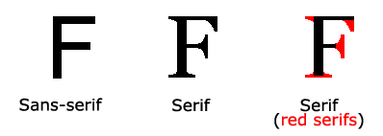

## **1.1 CSS Font Families**

In CSS, there are two types of font family names:

* generic family - a group of font families with a similar look (like "Serif" or "Monospace")
* font family - a specific font family (like "Times New Roman" or "Arial")

|  |  |  |
| --- | --- | --- |
| Generic family | Font family | Description |
| Serif | Times New Roman  Georgia | Serif fonts have small lines at the ends on some characters |
| Sans-serif | Arial  Verdana | "Sans" means without - these fonts do not have the lines at the ends of characters |
| Monospace | Courier New  Lucida Console | All monospace characters have the same width |

## **1.2 Font Style**

The font-style property is mostly used to specify italic text.

This property has three values:

* normal - The text is shown normally
* italic - The text is shown in italics
* oblique - The text is "leaning" (oblique is very similar to italic, but less supported)

**Example:**

p.normal {

font-style: normal;

}

p.italic {

font-style: italic;

}

p.oblique {

font-style: oblique;

}

**Looks Like:**

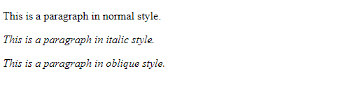

## 

## 

## 

## 

## 

## 

## **1.3 Font Size**

The font-size property sets the size of the text.

Being able to manage the text size is important in web design. However, you should not use font size adjustments to make paragraphs look like headings, or headings look like paragraphs.

Always use the proper HTML tags, like <h1> - <h6> for headings and <p> for paragraphs.

The font-size value can be an absolute, or relative size.

**Absolute size:**

* Sets the text to a specified size
* Does not allow a user to change the text size in all browsers (bad for accessibility reasons)
* Absolute size is useful when the physical size of the output is known

**Relative size:**

* Sets the size relative to surrounding elements
* Allows a user to change the text size in browsers

***Note:*** *If you do not specify a font size, the default size for normal text, like paragraphs, is 16px (16px=1em).*

**Example:**

h1 {

font-size: 40px;

}

h2 {

font-size: 30px;

}

p {

font-size: 14px;

}

**Output:**

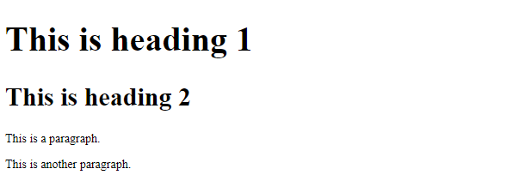

## 

## **1.4 Font Weight**

The font-weight property specifies the weight of a font:

### 

### **Example:**

p.normal {

font-weight: normal;

}

p.thick {

font-weight: bold;

}

**Looks Like:**

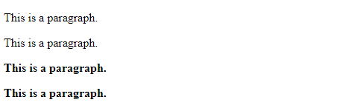

## 

## **1.5 Responsive Font Size**

The text size can be set with a vw unit, which means the "viewport width".

That way the text size will follow the size of the browser window:

<h1 style="font-size:10vw">Hello World</h1>

Viewport is the browser window size. 1vw = 1% of viewport width. If the viewport is 50cm wide, 1vw is 0.5cm.

## **1.6 Font Variant**

The font-variant property specifies whether or not a text should be displayed in a small-caps font.

In a small-caps font, all lowercase letters are converted to uppercase letters. However, the converted uppercase letters appears in a smaller font size than the original uppercase letters in the text.

### **Example:**

p.normal {

font-variant: normal;

}

p.small {

font-variant: small-caps;

}

**Looks Likes:**

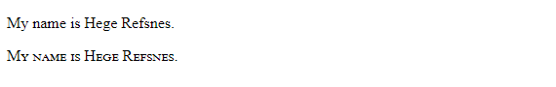

**2. CSS Text**

This text is styled with some of the text formatting properties. The heading uses the text-align, text-transform, and color properties. The paragraph is indented, aligned, and the space between characters is specified. The underline is removed from this colored ["Try it Yourself"](https://www.w3schools.com/css/tryit.asp?filename=trycss_text) link.

## **2.1 Text Color**

The color property is used to set the color of the text. The color is specified by:

* a color name - like "red"
* a HEX value - like "#ff0000"
* an RGB value - like "rgb(255,0,0)"

Look at [CSS Color Values](https://www.w3schools.com/cssref/css_colors_legal.asp) for a complete list of possible color values.

The default text color for a page is defined in the body selector.

**Example:**

body {

color: blue;

}

h1 {

color: green;

}

**Looks Likes:**

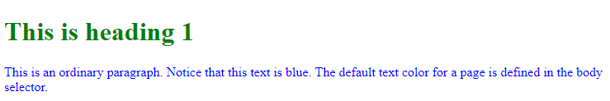

## 

## 

## **2.2 Text Alignment**

The text-align property is used to set the horizontal alignment of a text.

A text can be left or right aligned, centered, or justified.

The following example shows center aligned, and left and right aligned text (left alignment is default if text direction is left-to-right, and right alignment is default if text direction is right-to-left):

### **Example**

h1 {

text-align: center;

}

h2 {

text-align: left;

}

h3 {

text-align: right;

}

**Looks Likes:**

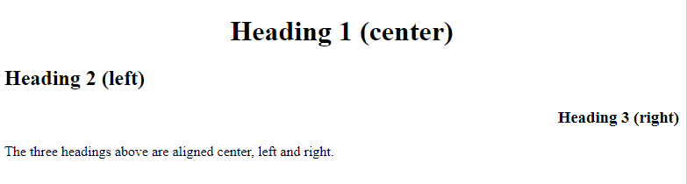

**2.3 Other Text Properties:**

|  |  |
| --- | --- |
| Property | Description |
| [color](https://www.w3schools.com/cssref/pr_text_color.asp) | Sets the color of text |
| [direction](https://www.w3schools.com/cssref/pr_text_direction.asp) | Specifies the text direction/writing direction |
| [letter-spacing](https://www.w3schools.com/cssref/pr_text_letter-spacing.asp) | Increases or decreases the space between characters in a text |
| [line-height](https://www.w3schools.com/cssref/pr_dim_line-height.asp) | Sets the line height |
| [text-align](https://www.w3schools.com/cssref/pr_text_text-align.asp) | Specifies the horizontal alignment of text |
| [text-decoration](https://www.w3schools.com/cssref/pr_text_text-decoration.asp) | Specifies the decoration added to text |
| [text-indent](https://www.w3schools.com/cssref/pr_text_text-indent.asp) | Specifies the indentation of the first line in a text-block |
| [text-shadow](https://www.w3schools.com/cssref/css3_pr_text-shadow.asp) | Specifies the shadow effect added to text |
| [text-transform](https://www.w3schools.com/cssref/pr_text_text-transform.asp) | Controls the capitalization of text |
| [text-overflow](https://www.w3schools.com/cssref/css3_pr_text-overflow.asp) | Specifies how overflowed content that is not displayed should be signaled to the user |
| [unicode-bidi](https://www.w3schools.com/cssref/pr_text_unicode-bidi.asp) | [Used together with the direction property to set or return whether the text should be overridden to support multiple languages in the same document](https://www.w3schools.com/cssref/pr_text_direction.asp) |
| [vertical-align](https://www.w3schools.com/cssref/pr_pos_vertical-align.asp) | Sets the vertical alignment of an element |
| [white-space](https://www.w3schools.com/cssref/pr_text_white-space.asp) | Specifies how white-space inside an element is handled |
| [word-spacing](https://www.w3schools.com/cssref/pr_text_word-spacing.asp) | Increases or decreases the space between words in a text |

**3. FONTs On the WEB**

Each device comes with its own pre-installed font selection. The selection is based largely on its operating system.

The problem is that every system differs a bit.

Windows-based devices might have one group. MacOS ones pull from another. Google’s own Android system uses their own as well.

Now pull up a website. Even this one would work. The font you see may not be the one original one intended.

Meaning: Let’s say the designer picked some obscure, paid font family for this site’s design. If you don’t have that font already installed and it’s not pulling from a web-friendly place – more on that later – the font *you see* would default back to some basic variation like Times New Roman.

The ‘Web safe’ ones, appear across all operating systems. They’re the small collection of fonts that overlap from Windows to Mac to Google (even Unix or Linux ones too).

They give designers (and website owners) the ability to specify which fonts to *fall back to* if needed. That way, you can control what shows up (no matter what) across all devices. And you can pick something that’s still *kinda* close to the original font (so that what your users wouldn’t see something random or out of place).

It’s a plan B, the ‘just-in-case’ version. An emergency system to save the world from bad font selections.

Got it? Good! Let’s take a look at the most popular web safe fonts to choose from.

### 

### **3.1. Arial**

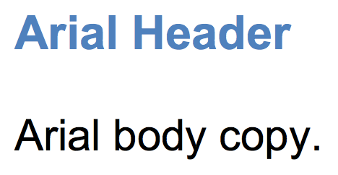

Arial is like the *de facto* standard for most.

It’s one of the most widely used sans-serif fonts (which means no little curls on the end of each letter). It’s often substituted on Windows devices for other interesting (read: more beautiful) font choices.

**3.2. Helvetica**

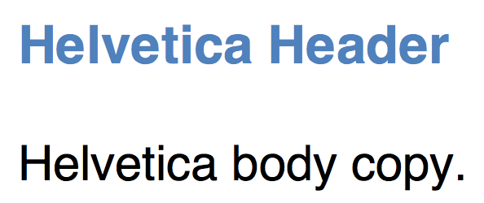

Helvetica is usually the designers’ go-to sans serif font. You can almost never go wrong with Helvetica (or at least using it as a fallback for most other choices).

**3.3. Times New Roman**

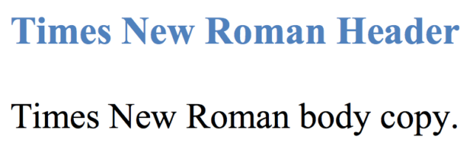

Times New Roman is to serif what Arial is to sans serif.

It’s among the most popular on Windows devices and is a new variation on the old Times font.

### **3.4. Times**

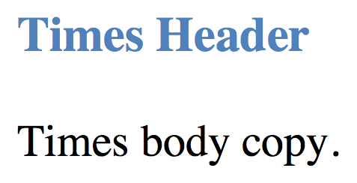

The Times font probably looks familiar. It’s the old newspaper print that you’re used to seeing in a small size in narrow columns. It’s about as traditional as it gets.

### **3.5. Courier New**

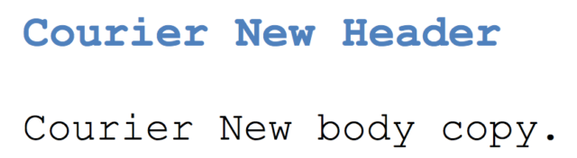

Courier New, similar to Times New Roman before it, is a variation of another old classic. It’s also considered a *monospaced* font (as opposed to the serif vs. sans serif we just saw).

**3.6. Courier**

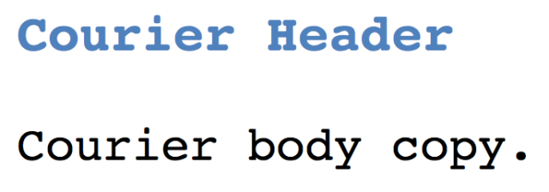

Courier is the old monospace stand-by available on almost all devices and operating systems.

### **3.7. Verdana**

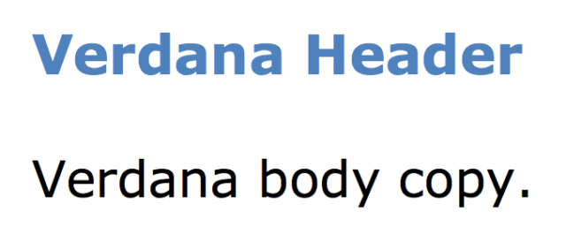

Verdana is a true web font because (1) the simple sans serif lines and (2) it’s super large size. The letters are almost elongated, which makes it easy to read online.

**3.8. Georgia**

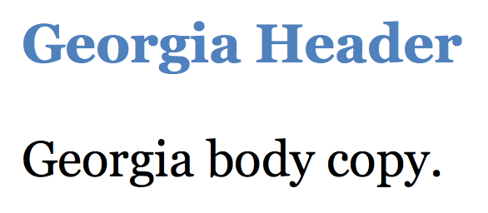

Georgia is similar to Verdana in size and stature (with bigger-than-usual letters compared with fonts of the same size). So while it’s great for certain circumstances, make sure to avoid pairing this serif font with others (like Times New Roman) which might look minuscule in comparison.

### 

### 

### **3.9. Palatino**

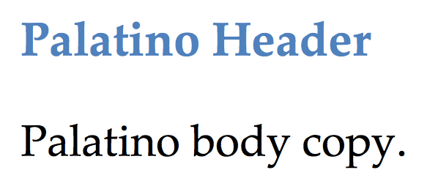

Palatino dates back to the Renaissance. [Seriously!](https://en.wikipedia.org/wiki/Palatino) It’s another large font that makes it perfect for the web, traditionally used for headings and print-style ads.

### 

### **3.10. Garamond**

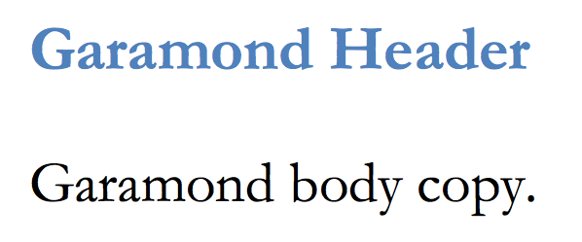

Garamond is another old-school font that dates back to styles used in [16th century Paris](https://en.wikipedia.org/wiki/Garamond). This new and improved version was introduced and bundled on most Windows devices (and has been adopted by others since).

### 

### **3.11. Bookman**

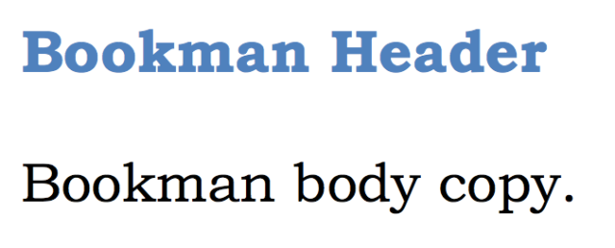

Bookman (or Bookman Old Style) is another perfect headline option that maintains legibility (or readability) even when used in a small size.

### 

### 

### 

### 

### 

### 

### 

### 

### 

### **3.12. Comic Sans MS**

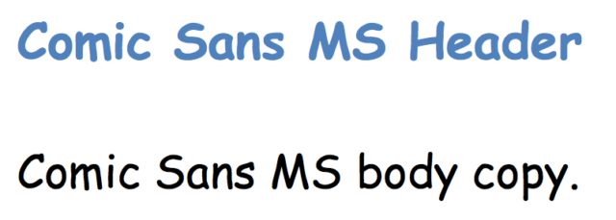

Comic Sans MS is a playful, whimsical alternative to other sans serif options.It’s also kinda fugly.

**3.13. Trebuchet MS**

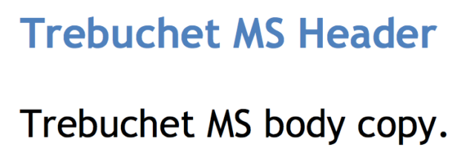

Trebuchet MS is a medieval-themed font [originally](https://en.wikipedia.org/wiki/Trebuchet_MS) designed by Microsoft in the mid-nineties. It was used on the XP version, and today commonly appears as body copy on the ‘net.

### **3.14. Arial Black**

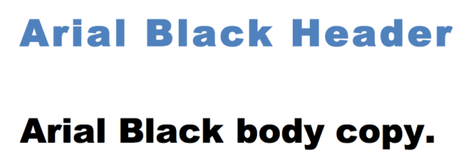

Arial Black is the bigger, bolder, badder version of your basic Arial. Funny enough, it also shares proportions with Helvetica. Why is that important? So that they could [originally](https://en.wikipedia.org/wiki/Arial) use it to replace Helvetica and print things without paying for the license.

### 

### 

### 

### 

### 

### 

### 

### 

### **3.15. Impact**

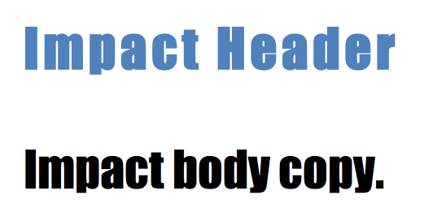

Impact is another bold headline choice that looks great in a few short words, and absolutely terrible in a sentence or longer.

# 

# 

# 

# 

# 

# 

# 

# 

# **4. CSS @font-face Rule**

With the @font-face rule, web designers do not have to use one of the "web-safe" fonts anymore.

In the @font-face rule you must first define a name for the font (e.g. myFirstFont), and then point to the font file.

Tip: Use lowercase letters for the font URL. Uppercase letters can give unexpected results in IE!

To use the font for an HTML element, refer to the name of the font (myFirstFont) through the font-family property:

div {

font-family: myFirstFont;

}

### **Example:**

Specify a font named "myFirstFont", and specify the URL where it can be found:

@font-face {

font-family: myFirstFont;

src: url(sansation_light.woff);

}

Looks Like:

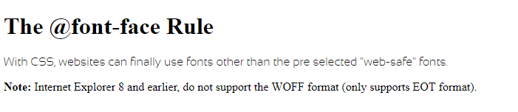

**5. Text Shadow**

The text-shadow property adds shadow to text.

This property accepts a comma-separated list of shadows to be applied to the text.

**Syntax**

text-shadow: *h-shadow v-shadow blur-radius color*|none|initial|inherit;

***Note:*** To add more than one shadow to the text, add a comma-separated list of shadows.

### **Example:**

Basic text-shadow:

h1 {

text-shadow: 2px 2px #ff0000;

}

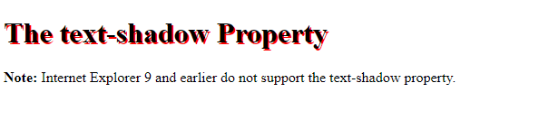

## 

## 

## **6.Property Values**

|  |  |
| --- | --- |
| Value | Description |
| *h-shadow* | Required. The position of the horizontal shadow. Negative values are allowed |
| *v-shadow* | Required. The position of the vertical shadow. Negative values are allowed |
| *blur-radius* | Optional. The blur radius. Default value is 0 |
| *color* | [Optional. The color of the shadow. Look at CSS Color Values for a complete list of possible color values](https://www.w3schools.com/cssref/css_colors_legal.asp) |
| none | Default value. No shadow |
| initial | [Sets this property to its default value. Read about initial](https://www.w3schools.com/cssref/css_initial.asp) |
| inherit | [Inherits this property from its parent element. Read about inherit](https://www.w3schools.com/cssref/css_inherit.asp) |

**6. Word Wrapping**

The word-wrap property allows long words to be able to be broken and wrap onto the next line.

## **CSS Syntax**

word-wrap: normal|break-word|initial|inherit;

### **Example:**

Allow long words to be able to break and wrap onto the next line:

div {

word-wrap: break-word;

}

**Looks Like:**

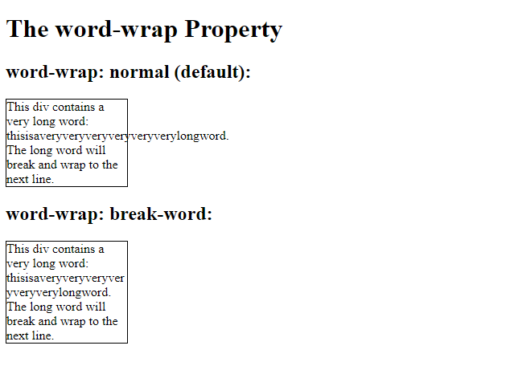

**References**

1. **https://www.w3schools.com/css/css_text.asp**
2. **https://www.w3schools.com/css/css_font.asp**
3. **https://websitesetup.org/web-safe-fonts-html-css/**
4. **https://www.w3schools.com/cssref/css3_pr_word-wrap.asp**
5. **https://www.w3schools.com/cssref/css3_pr_text-shadow.asp**